📄 Especificación Técnica: Modelo Entidad-Relación (ERD) Unificado Enterprise
Ficha Documental
- Proyecto: E-Commerce Cross-Border, Fulfillment & On-Demand Logistics Platform.
- Versión del Modelo: 2.0 (Integración 8 Dominios - ADR-001).
- Motor de BD de Referencia: PostgreSQL 16+.

🗺️ 1. Diagrama Arquitectónico de Entidades (ASCII Map)

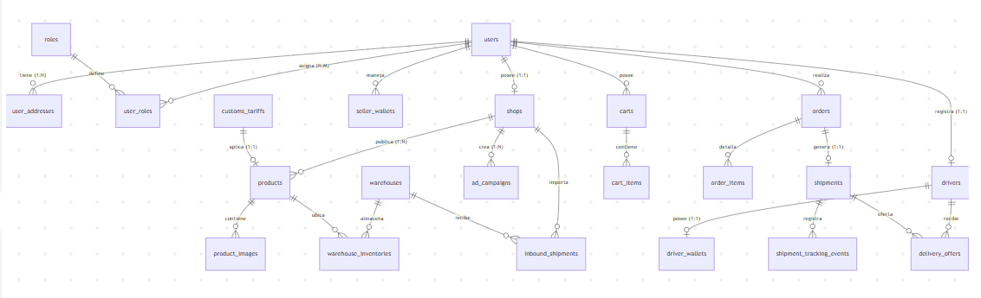

📐 2. Catálogo Detallado de Entidades por Dominio

Dominio 1: Usuarios, Seguridad y Direcciones
- users: id (UUID, PK), email (UNIQUE), password_hash, first_name, last_name, phone, is_active, created_at.
- roles: id (PK), code (ROLE_BUYER, ROLE_SELLER, ROLE_DRIVER, ROLE_WAREHOUSE_OPERATOR, ROLE_ADMIN).
- user_roles: user_id (FK -> users), role_id (FK -> roles).
- user_addresses: id (PK), user_id (FK -> users), street, city, state, postal_code, country_code, latitude, longitude, is_default.

Dominio 2: Catálogo y Tiendas
- shops: id (UUID, PK), owner_id (FK -> users), name, slug, rating, is_verified, created_at.
- categories: id (PK), parent_id (FK autoreferencial), name, slug, commission_percentage.
- customs_tariffs: id (PK), hs_code (NCM/HS Code), duty_tax_rate (%), vat_rate (%).
- products: id (UUID, PK), shop_id (FK -> shops), category_id (FK -> categories), customs_tariff_id (FK -> customs_tariffs), title, description, price, sku, weight_kg, dimensions_cm (L, W, H), status (ACTIVE, PAUSED, OUT_OF_STOCK).
- product_images: id (PK), product_id (FK -> products), url, is_primary.

Dominio 3: Transacciones y Carrito
- carts: id (UUID, PK), buyer_id (FK -> users), updated_at.
- cart_items: id (PK), cart_id (FK -> carts), product_id (FK -> products), quantity.
- orders: id (UUID, PK), buyer_id (FK -> users), shipping_address_id (FK -> user_addresses), total_products_amount, total_shipping_amount, total_tax_amount, grand_total, status (PENDING_PAYMENT, PAID, IN_FULFILLMENT, SHIPPED, DELIVERED, CANCELLED), payment_ref.
- order_items: id (PK), order_id (FK -> orders), product_id (FK -> products), shop_id (FK -> shops), quantity, unit_price, platform_commission_fee, seller_net_payout.

Dominio 4: Finanzas y Publicidad (Retail Media)
- seller_wallets: id (PK), shop_id (FK -> shops, UNIQUE), available_balance, pending_clearance_balance, currency.
- wallet_transactions: id (PK), wallet_id (FK -> seller_wallets), amount, type (SALE_PAYOUT, COMMISSION_DEDUCTION, AD_CAMPAIGN_CHARGE, WITHDRAWAL), reference_id.
- ad_campaigns: id (PK), shop_id (FK -> shops), product_id (FK -> products), daily_budget, cpc_bid, spent_total, status (ACTIVE, PAUSED, EXHAUSTED), impressions_count, clicks_count.

Dominio 5: Logística, Transporte Híbrido y Tracking
- shipments:
  - id (UUID, PK), order_id (FK -> orders).
  - fulfillment_type (EXTERNAL_COURIER, ON_DEMAND_DRIVER, WAREHOUSE_CROSS_DOCK).
  - assigned_driver_id (FK -> drivers, NULL si es courier).
  - carrier_name (DHL, FedEx, etc.; NULL si es driver).
  - tracking_number, shipping_cost_buyer, shipping_cost_actual, driver_payout_amount.
  - pickup_address_id (FK -> user_addresses), delivery_address_id (FK -> user_addresses).
  - status (PREPARING, OFFERED_TO_DRIVERS, ASSIGNED, IN_TRANSIT, DELIVERED, FAILED).
- shipment_tracking_events: id (PK), shipment_id (FK -> shipments), status_description, location_name, latitude, longitude, timestamp.

Dominio 6: Red de Conductores On-Demand (Crowdsourced Logistics)
- drivers: id (UUID, PK), user_id (FK -> users, UNIQUE), vehicle_type (BIKE, MOTORCYCLE, CAR, VAN, TRUCK), license_plate, driver_license_number, is_verified, is_online, current_latitude, current_longitude, rating_score.
- driver_wallets: id (PK), driver_id (FK -> drivers, UNIQUE), available_balance, currency.
- delivery_offers: id (PK), shipment_id (FK -> shipments), driver_id (FK -> drivers), offered_payout, status (PENDING, ACCEPTED, REJECTED, EXPIRED), created_at.

Dominio 7: Warehouse & Fulfillment
- warehouses: id (PK), name, address_id (FK -> user_addresses), storage_capacity_m3.
- warehouse_inventories: id (PK), warehouse_id (FK -> warehouses), product_id (FK -> products), stock_quantity, allocated_quantity, aisle_location.
- fulfillment_rates: id (PK), storage_monthly_rate_m3, pick_and_pack_unit_fee.

Dominio 8: Aduanas e Importaciones (Cross-Border)
- inbound_shipments: id (UUID, PK), shop_id (FK -> shops), destination_warehouse_id (FK -> warehouses), origin_country, total_declared_value_usd, status (SHIPPED_FROM_ORIGIN, IN_CUSTOMS, DUTIES_PAID, RECEIVED_IN_WAREHOUSE).
- customs_declarations: id (PK), inbound_shipment_id (FK -> inbound_shipments), hs_code_id (FK -> customs_tariffs), duties_amount_paid, clearance_fee_platform, cleared_at.

🔄 3. Reglas Integrales de Integración Relacional
- Aislación del Core Financiero: Las comisiones de venta (order_items), cobros por campañas (ad_campaigns) y liquidaciones de fletes (shipments) impactan en tablas independientes de billetera (seller_wallets y driver_wallets) mediante transacciones auditables (wallet_transactions).
- Orquestación del Envío: Un shipment pertenece a una orden order. Según el fulfillment_type, el backend decide si crea un registro en delivery_offers enviando una notificación WebSocket a conductores cercanos (drivers), o si asigna directamente un proveedor logístico externo.
- Consistencia de Inventario: El stock se actualiza en warehouse_inventories si el vendedor usa servicios de Fulfillment, o directamente en el inventario base del producto si es envío directo desde la tienda.

